Instructions for Try Booking

If you are intending to attend both the dinner on the Tuesday evening and the meeting on Wednesday morning, this is a tip to save you time registering:
- Select the dinner option and then select as many tickets for the people you are registering for then
- Hit next to put the intended purchase of tickets into the cart
- This will get you to this page

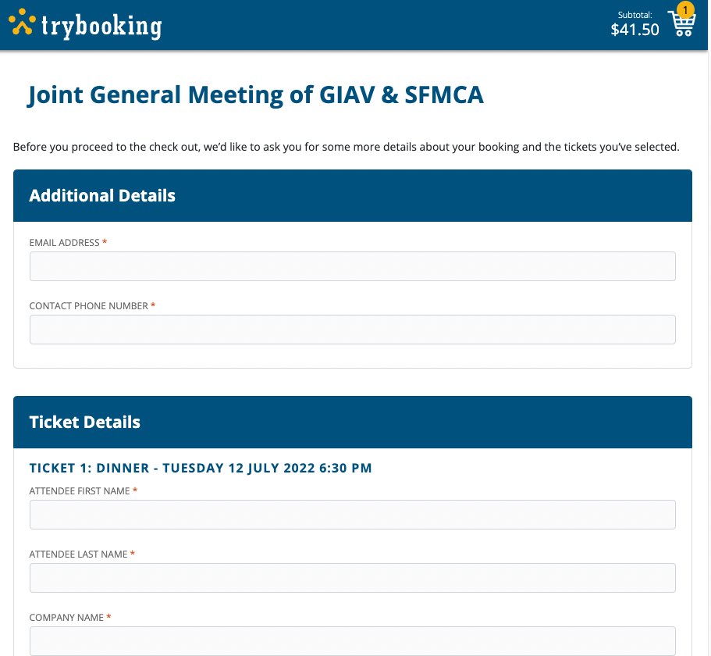
- Then, rather than completing this page, hit Back and Back again to reach the initial screen where you can then register for the meeting
- Select the number of tickets for the people you are registering and hit next
- This will be the screen where you can enter the purchaser’s details once and the name and company of the people who are attending for each of the tickets for the dinner and meeting
- Once completed you will be taken to the payment page to checkout

