GIAV Golf Day & Dinner - Monday February 26 2018

The Grain Industry Association of Victoria (GIAV) and our Major Sponsor GrainCorp Operations Ltd invite members and colleagues to our annual Golf Day and dinner.

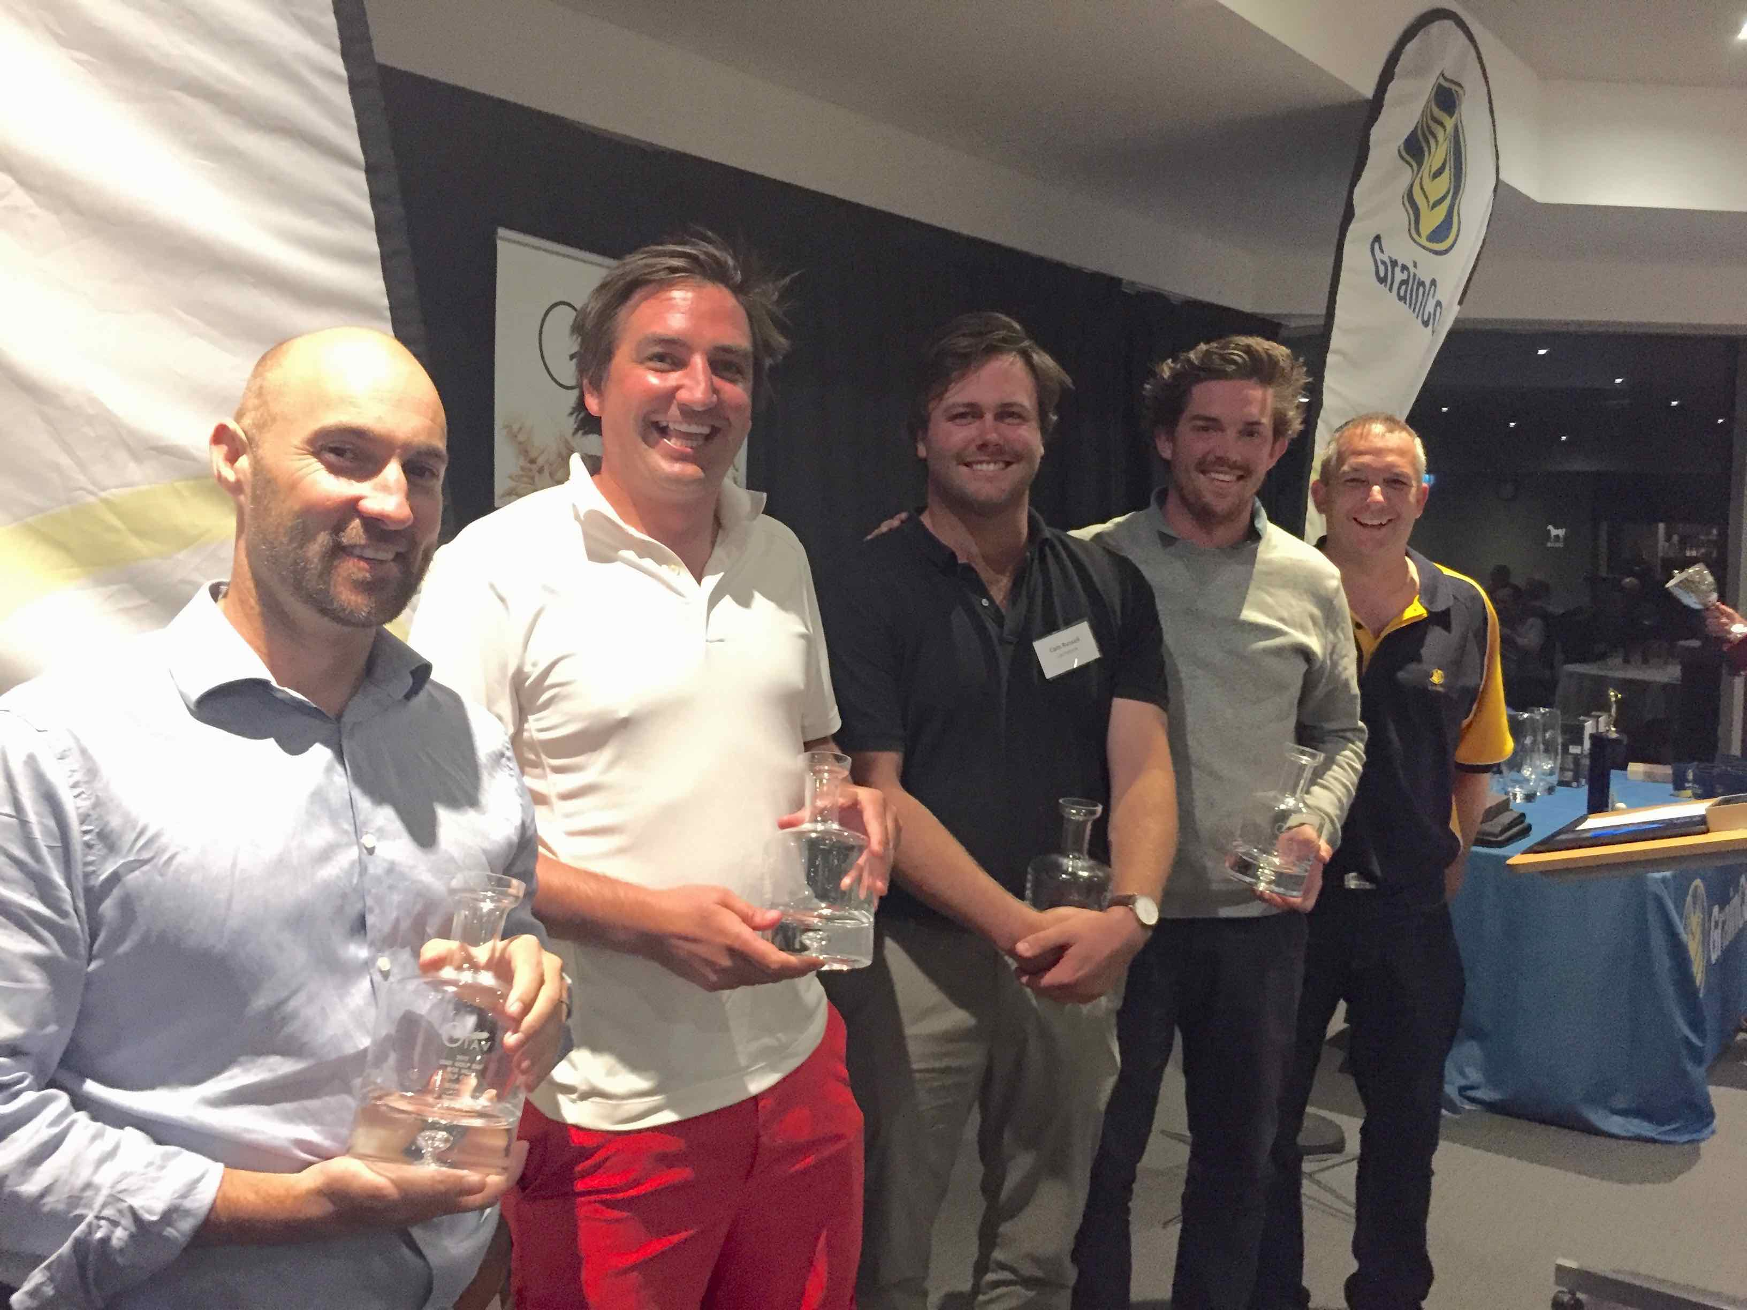

Box Hill Golf Club, 202 Station St, Box Hill South  Registration and pre-lunch putting comp starts at 11:30. Tee off at 12:30 pm - Shotgun start – Ambrose format | Dinner 6:30pm for 7:00 pm. Dress: Collared shirt, dress pants or acceptable length shorts, long or short socks and soft spike shows (not runners) required on course

The INTL FCStone Put Option - A putting comp with prizes before and after play

TAX INVOICE On completion this form becomes a receipt ABN: 56 556 354 727
Activity | Option | Cost (inc. GST)
Golf Lunch & Dinner | A | $130
Golf & Lunch | B | $90
Dinner only | C | $70
No refunds for cancellations after February 19. Complete this form and forward it to:
fax 03 9818 2444
post GIAV PO Box 2252, Hawthorn, Vic, 3122
email giav@giav.com.au

Major Sponsor:
Player Name | Golf Handicap | Activity Option | Cost
1.
2.
3.
4
Total Payment | Highest 27 for men and 36 for women

Please charge $___________ to my credit card Visa □ Mastercard □

Name on card_____________________________________________ Signature: ____________________________

Card No. __ __ __ __ __ __ __ __ __ __ __ __ __ __ __ __ Expiry Date: ___________ CVV __________

Direct deposit to GIAV (please quote your company name) BSB: 083 231 Account No. 48725 4079
I enclose cheque (payable to GIAV)

Enquiries and Bookings Colin Peace: m: 0413 835 793 e: giav@giav.com.au
More information see ‘Events’ on www.giav.com.au

